Analysis of Simple Mediation Model Base on Regression & Process
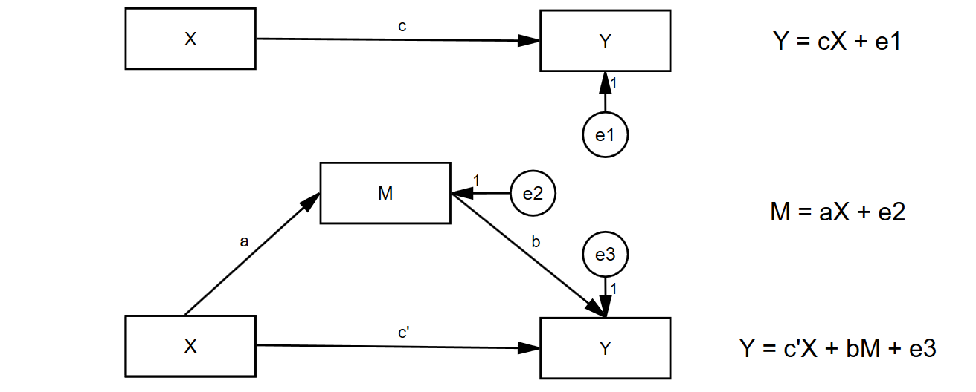
Note:
1.Mediation Model
1.1Complete Mediation: X -> M -> Y: c’= 0 and a*b 95% Bootstrap CI does not include zero(Theoretically pure but statistically rare);
1.2Partial Mediation: X -> Y & X -> M -> Y: c’≠ 0 and a*b 95% Bootstrap CI does not include zero.
2.Effect of X on Y
2.1Total Effect: c(c = a*b + c’);
2.2Indirect Effect: a*b(Proportion Mediated:a*b/c); 2.3Direct Effect: c’(Proportion of Direct Effect:1 - a*b/c).

Table1.Model coefficients for the Simple-Mediation.
Independent  Variables | Dependent Variable
Independent  Variables | Y |  |  |  |  |  | M |  |  |  |  |  | Y
Independent  Variables | B | SE | Beta | t | LLCI | ULCI | B | SE | Beta | t | LLCI | ULCI | B | SE | Beta | t | LLCI | ULCI
(Constant) | 2.079 | 0.365 |  | 5.688*** | 1.359 | 2.799 | 0.555 | 0.374 |  | 1.483^{N.S.} | -0.182 | 1.293 | 1.832 | 0.327 |  | 5.596*** | 1.187 | 2.476
X | 0.623^{c} | 0.073 | 0.477 | 8.592*** | 0.480 | 0.766 | 0.651ª | 0.074 | 0.485 | 8.765*** | 0.505 | 0.797 | 0.333^{c’} | 0.074 | 0.255 | 4.504*** | 0.187 | 0.478
M |  |  |  |  |  |  |  |  |  |  |  |  | 0.445^{b} | 0.055 | 0.458 | 8.094*** | 0.337 | 0.554
 | R-Sq=0.228 |  |  |  |  |  | R-Sq=0.235 |  |  |  |  |  | R-Sq=0.389,Adj. R-Sq=0.384,  ΔR-Sq^{A}=0.161,ΔF(1,249)=65.505***
 | F(1,250)=73.891*** |  |  |  |  |  | F(1,250)=76.824*** |  |  |  |  |  | F(2,249)=79.185***
Note: ^{N.S.} : No Significant;***:p<0.001.
^{A}:(Incremental variance explained) R-Sq¹ - R-Sq² ( ¹ : Predictors : (Constant) , X ; ² : Predictors : (Constant) , X , M . Note : Hierarchical Regression)

Table2.Effect of X On Y.
Total Effect of X on Y
Effect | SE | t | LLCI | ULCI | Proportion
0.623^{c} | 0.073 | 8.592*** | 0.480 | 0.766 | /
Direct Effect of X on Y
Effect | SE | t | LLCI | ULCI | Proportion
0.333^{c’} | 0.074 | 4.504*** | 0.187 | 0.478 | 0.53
Indirect Effect of X on Y:X->M->Y
Effect | Std.Effect | BootSE | BootLLCI | BootULCI | Proportion
0.290^{a*b} | 0.222 | 0.047 | 0.202 | 0.386 | 0.47
Note:***:p<0.001.
Level of confidence = 95% ; Number of Bootstrap Samples = 1000.

